**Part 1: Business Description and Supply Chain**

Business Description: Unconventional Housing Creations is a unique housing project company operating in the United States. Our mission is to provide innovative housing solutions for non-human customers, primarily targeting domesticated pets, including dogs and cats. We aim to offer a range of unconventional housing options that cater to the comfort, safety, and entertainment needs of these furry companions. Our company envisions a world where pets have their own unique and exciting living spaces, making their lives happier and more enriched.

**Company Size and Locations:**

1. **Estimated Company Size:** Initially, our company will consist of a core team of 15 people, including architects, designers, engineers, customer service, and sales representatives. As our business grows, we anticipate expanding our workforce to accommodate the demand.
2. **Company Locations:** Our primary office is located in a pet-friendly city in the USA. To provide efficient services to our customers, we plan to operate in multiple cities across the country. These locations will serve as production centers, showrooms, and distribution points to meet the diverse needs of our non-human clients.

**Supply Chain:**

1. **Raw Materials: a. Bio-Safe Materials:**

We use bio-safe materials that are non-toxic and pet-friendly. These materials include recycled plastics, organic fabrics, and sustainable woods. b. Innovative Technology Components: Our unconventional pet houses may incorporate interactive technology. Components such as sensors, LED lights, and temperature control systems are essential. c. Themed Accessories: To make our pet houses more appealing, we source themed accessories like miniature furniture, artificial grass, and customized paintings to personalize each home.

1. **Material Sources:**

**a. Bio-Safe Materials:**

* + Recycled Plastics: Sourced from local recycling facilities that specialize in creating eco-friendly plastics.
  + Organic Fabrics: Sourced from certified organic fabric suppliers.
  + Sustainable Woods: Responsibly sourced from nearby sustainable forestry initiatives.

**b. Innovative Technology Components:**

* + Local Technology Providers: Collaborating with local technology companies specializing in pet oriented IoT devices and home automation.

**c. Themed Accessories:**

* + Artisan Crafters: Partnering with local artisans and craftsmen who create unique pet-themed accessories.

1. **Primary Office and Cities of Operation:**

Our primary office is based in a pet-friendly city in the USA. We plan to operate in multiple cities across the country, including but not limited to:

* + [New York City, New York]: Our headquarters and primary production facility.
  + [Los Angeles, California]: A showroom and distribution center.
  + [Chicago, Illinois]: A production and customer service center.
  + [Miami, Florida]: A showroom and design center.

**Part 2: Network Architecture Model**

The network architecture model provided is a high-level representation of the components involved in our unconventional housing project company's network. It focuses on the core components and their relationships without delving into specific technical details.

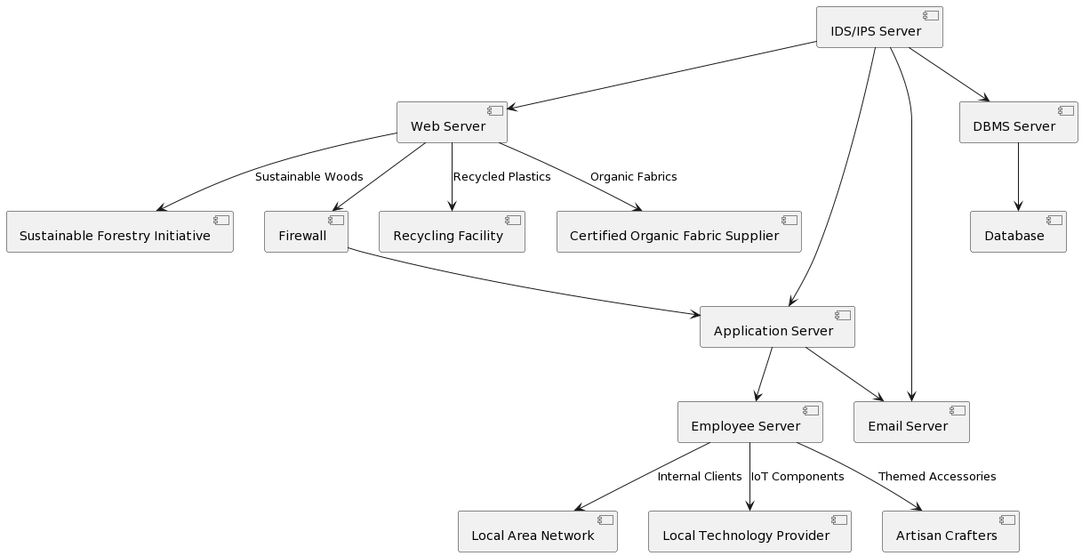

In this network architecture:

* The Web Server serves as the front end of our business, hosting our website where customers can explore and order unique pet houses.
* The External Firewall filters connections from the Web Server, providing a layer of security against potential threats.
* The Application Server hosts various applications, including our sales tools and employee apps. It also serves the necessary APIs to the website.
* The Email Server manages internal and external communications for our team.
* The Employee Server connects to a LAN (Local Area Network) where internal clients, such as our employees, access company resources.
* The IDS/IPS (Intrusion Detection System and Intrusion Protection System) Server ensures network security by monitoring and protecting against potential intrusions.
* The DBMS (Database Management System) Server and Database are well-protected behind the IDS/IPS layer, safeguarding sensitive customer data and business information.

This architecture provides a secure and efficient framework for our unconventional housing project company, ensuring the smooth operation of our website, communication, and data management while safeguarding against potential security threats.